Handouts for Activating Student Learning

Case Study 1
A lower division (freshman-level) general education mathematics course taught on

ground (MATH 1010 or 1710).

The difference is in the details:

Daily Agenda:

Math Buddies:
Students required to have at least two classmates as Math Buddies;

Grade Report Forms:

During Class:
In class activities allow introducing, modeling, and reinforcing

Dr. O’s Three R’s Learning Cycle:
- Review what you’ve done;

- Reflect on the what, how, and why of what you’ve done; and

- Revise your plan based on your reflection.

Next, try your new plan and apply the three R’s (Otts, 14 June 2011).

Group or Individual Presentation:

We’re all in this together:
Focuses on students rather than merely content.

Emphasize learning, problem solving, test taking, and transfer of skills.

Best moment occurred when, for the umpteenth time, a student asked, “What’s

the right answer?” to an item and another student said, “No! You’re asking the wrong question.” When asked to explain, the second student replied, “Don’t ask, ‘What’s the right answer’; ask ‘How can I get the right answer.’”

Follow on questions:

For additional examples, see:
Dr. O’s home page: www.mtsu.edu/~dotts
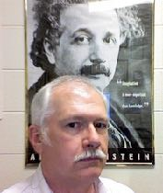

Possible, Maxine | Grade | Tot Pts | T-tot | T1 | T2 | T3 | T4 | T5 | T6 | Final
K-nn Fall 2017 | 100.0% | 303 | 200 | 100 | 100
Homework must be 100% complete | MML | 33 | Voc Tot | V1 | V2 | V3 | V4 | V5 | V6 | Prestn
and correct. | Quizzes | 10 | 20 | 10 | 10 |  |  |  |  | 40
faux student | Ex Cred | 0 | RC-tot | R1 | R2 | R3 | R4 | R5 | GRF | RoT
 | Attend |  | 0
Frosh, Mary | Grade | Tot Pts | T-tot | T1 | T2 | T3 | T4 | T5 | T6 | Final
K-0 Fall 2017 | 96.0% | 291 | 172 | 88 | 84
Homework must be 100% complete | MML | 33 | Voc Tot | V1 | V2 | V3 | V4 | V5 | V6 | Prestn
and correct. | Quizzes | 10 | 20 | 10 | 10 |  |  |  |  | 45
 | Ex Cred | 5 | RC-tot | R1 | R2 | R3 | R4 | R5 | GRF | RoT
 | Attend |  | 6 | 6
Student, Chuck | Grade | Tot Pts | T-tot | T1 | T2 | T3 | T4 | T5 | T6 | Final
K-0 Fall 2017 | 84.8% | 257 | 156 | 76 | 80
Homework must be 100% complete | MML | 17 | Voc Tot | V1 | V2 | V3 | V4 | V5 | V6 | Prestn
and correct. | Quizzes | 8 | 17 | 8 | 9 |  |  |  |  | 42
 | Ex Cred | 5 | RC-tot | R1 | R2 | R3 | R4 | R5 | GRF | RoT
 | Attend |  | 12 | 12
Tender, Pree | Grade | Tot Pts | T-tot | T1 | T2 | T3 | T4 | T5 | T6 | Final
K-0 Fall 2017 | 66.7% | 202 | 132 | 64 | 68
Homework must be 100% complete | MML | 0 | Voc Tot | V1 | V2 | V3 | V4 | V5 | V6 | Prestn
and correct. | Quizzes | 6 | 12 | 5 | 7 |  |  |  |  | 40
 | Ex Cred |  | RC-tot | R1 | R2 | R3 | R4 | R5 | GRF | RoT
 | Attend |  | 12 | 12
Average, Class | Grade | Tot Pts | T-tot | T1 | T2 | T3 | T4 | T5 | T6 | Final
K-0 Fall 2017 | 82.51% | 250 | 153.33 | 76.00 | 77.33 | 0.00 | 0.00 | 0.00 | 0.00 | 0.00
Homework must be 100% complete | MML | 16.67 | Voc Tot | V1 | V2 | V3 | V4 | V5 | V6 | Prestn
and correct. | Quizzes | 8.00 | 16.33 | 7.67 | 8.67 | 0.00 | 0.00 | 0.00 | 0.00 | 42.33
 | Ex Cred | 3.33 | RC-tot | R1 | R2 | R3 | R4 | R5 | GRF | RoT
 | Attend |  | 10.00 | 10.00 | 0.00 | 0.00 | 0.00 | 0.00 | 0.00 | 0.00

Case Study 2
Upper division (graduating senior) capstone course for Liberal Studies and Professional Studies majors
Who: What: How:
use integrative and reflective thinking to develop their ePortfolio.

requires students to:

- complete a personal introduction

- write professional goals, and

- reflections and evidence of knowledge and skills gained

knowledge and skill section

Students

identify competencies achieved and upload artifacts corresponding reflection
Better prepared for interviews

The ePortfolio is a valuable self-discovery exercise.

Benefits to Students

The reflective and integrative thinking assignment can be a final assignment in any class.
Students would benefit from identifying the knowledge and skills gained.

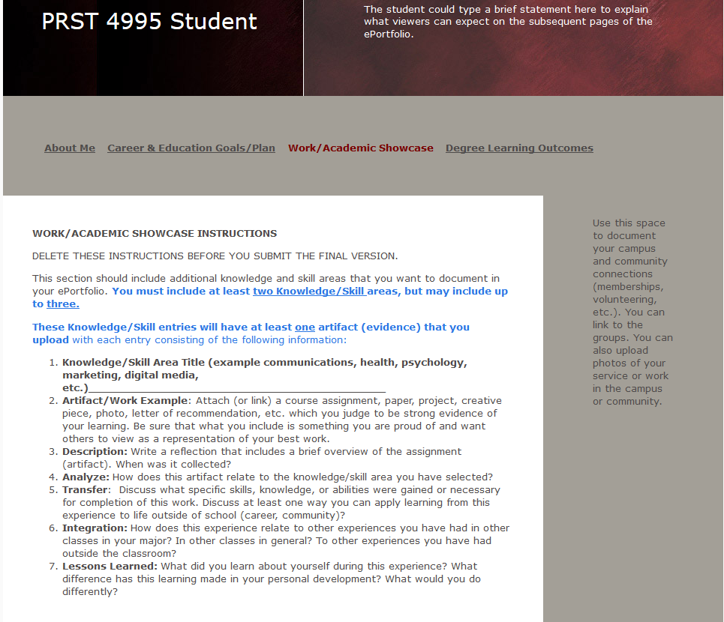

Case Study 3
Graduate Higher Education Course

Step 1. A topic for each class meeting is assigned to the entire class at the beginning of the course. (For this example, the topic is For Profit Higher Education)

Step 2. Before the class meeting where the topic will be discussed, students review the current literature and choose five refereed academic journal articles on the assigned topic that best answer the following questions and provides citations on where the information was found:

Questions for the For Profit Higher Education assignment are:
- What are the differences between: a state funded university, a non-profit institution, and a for-profit school?
- Why does the federal government seem to dislike for-profit schools?
- Why do faculty at for-profit schools tend to not like their jobs?
- Why do some employers tend to not choose graduates of for-profit schools?

Step 3. Students present their findings to the class.

Step 4. Class lecture and activities.

Step 5. The class is presented with a cast study on the topic. (This case study is based on IPEDS
data and students learn the retention and graduation rates of various kinds of schools)

Step 6. As a reflective activity, students answer the following question:

It is becoming more common for graduates of for-profit schools to seek a second undergraduate diploma from a large state school (in an effort to enhance their employability). What are your recommendations for MTSU’s Administration?

References

American Association of Colleges and Universities & Carnegie Foundation for the Advancement of Teaching. (2004). A statement on integrative learning. Retrieved from http://evergreen.edu/ washingtoncenter/docs/intlearning/statementintlearning.pdf
American Association of Colleges and Universities. (2009). Integrative and Applied Learning VALUE Rubric. Retrieved from http://www.AAC&U.org/value/rubrics/integrative-learning
Ash, S. L. & Clayton, P. H. (2009). Generating, deepening, and documenting learning: The power of critical reflection in applied learning. Journal of Applied Learning in Higher Education, 1, 25-48.
Boylan, H. R. (2002). What works: Research-based practices in developmental education. Boone, NC: Continuous Quality Improvement Network with the Center for Developmental Education.
Catalyst for Learning. ePortfolio Resources and Research. Retrieved from http://c2l.mcnrc.org/pedagogy/
Chen, H. L., & Light, T. P. (2010). Electronic portfolios and student success: Effectiveness, efficiency, and learning. Washington, D.C.: Association of American Colleges and Universities
Eynon, B., Gambino, L.M., Torok, J. (2014, Winter). Completion, quality, and change: The difference e-Portfolios make. Peer Review, 16 (1).
Eynon, B., Gambino, L. M., & Török, J. (2014). “Inquiry, Reflection and Integration: Catalyst Design Principles” Retrieved from http://c2l.mcnrc.org/framework/
Griffin, T. J. Learning that lasts: Helping students remember and use what you teach. Retrieved from: www/facultyfocus.com/articles/effective-teaching-stratefies/learning-lasts-helping-students-remember-use-teach/
Jackson, R. R. (February 2010). Start where your students are. Educational Leadership 67(5) pp. 6-10.
Jenkins, R. (March 16, 2015). The 4 properties of powerful teachers. The Chronicle Of Higher Education.
Knowles, M. S. (1980). The modern practice of adult education: From pedagogy to andragogy (Revised and updated). Englewood Cliff, NJ: Prentice Hall Regents.
Krathwohl, D. R., Bloom, B. S., & Masia, B. B. (March, 1969). Taxonomy of educational objectives: The clasification of educational goals: Hanbook II: Affective domain. David McKay Co. Inc. New York.
Mezirow, J. (1990). How critical reflection triggers transformative learning. In J. Mezirow & Associates (Eds.), Fostering critical reflection in adulthood: A guide to transformative and emancipatory learning (pp. 1-20). San Francisco: Jossey Bass.
Peet, M., Lonn, S., Gurin, P., Boyer, K.P., Matney, M., Marra, T., Taylor, S.H., Daley, A. (2011). Fostering integrative knowledge through ePortfolios. International Journal of ePortfolio, 1(1), 11-31. http://www.theijep.com/pdf/IJEP39.pdf
Peet M. The Integrative Knowledge Portfolio Process: A Program Guide for Educating Reflective Practitioners and Lifelong Learners (Out of Print) . MedEdPORTAL; 2010. Available from: www.mededportal.org/publication/7892
Rafeldt, L.A., Bader, H.J., Czarzasty, N.L., Freeman, E., Quellet, E., Snayd, J.M. (2014, Winter). Reflection builds twenty-first century professionals. Peer Review, 16 (1).
Rhodes, T. L. (2011). Making learning visible and meaningful through electronic portfolios. Change, 43(1), 6-13. doi:10.1080/00091383.2011.538636
Roth, M. S. (2010, January 3). Beyond critical thinking. The Chronicle Of Higher Education. Retrieved from: http://www.chronicle.com/article/Beyond-Critical-Thinking/63288
Weimer, M. (15 August 2017). Teacher characteristics and behaviors that make a difference. Retrieved from: www/facultyfocus.com/articles/teaching-professor-blog/teacher-characterisitcs-that-make-a-difference/

